Timothy WEBB  12, rue Rossini  06000 NICE (France)  Tel: +33 493 872 444 - e-mail: tim@webb.fr  www.traducteur-juridique.fr  Date of birth: 2nd June, 1961  Nationality: British  Family status: Married, 2 children | 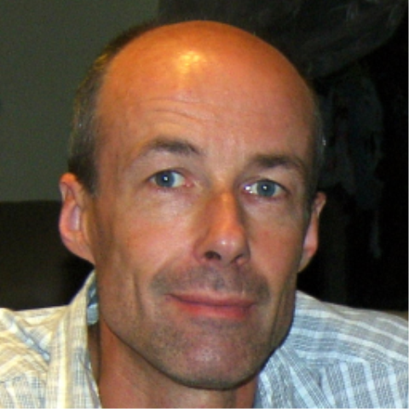
Mother tongue: English

EDUCATION – QUALIFICATIONS
May 2014 | Awarded IoLET Dip.Trans (semi-specialised legal text)
January 2013 | Passed translation assessment (FR > EN – Business) for qualified membership of I.T.I.
1981 - 1985 | University of Surrey  BSc in Hotel and Catering Administration, including a 12-month industrial placement in Hotel St Raphael, HAMBURG (Germany)
1974-1979 | Lancing College, Sussex  3 A Levels : English (B), German (D), Economics (D)
EMPLOYMENT
1999 - present | Full-time freelance translator/interpreter, NICE (France).
1990 - 1998 | Part-time self-employed translator/interpreter, NICE (France). French > English
Nov 1987 - 1999 | Founder/manager of "VSP Formalities", NICE (France) - company formalities and business services

WORK CARRIED OUT AS TRANSLATOR/INTERPRETER: specialised in legal and property fields since 1990

Translation:
- deeds, contracts, judgements and summonses for French notaries, avocats and process servers.
- building specifications, architect's surveys, construction contracts, company documents, loans, balance sheets
- certified translations of civil status certificates, diplomas, etc.
- court documents into French and English
- website: www.sarf.fr/index_EN.php (tax)

Interpreting:
- meetings between French notaries and their clients, signing property transactions, marriage contracts and other notarial deeds (consecutive interpreting)
- business meetings for local companies - take-over negotiations, valuation procedures, product presentations, redundancy and dismissal procedures (simultaneous and ad hoc interpreting)
- building site meetings and condominium meetings
- interpreting for police and courts in France and Monaco (simultaneous and ad hoc interpreting)

CONTINUOUS PROFESSIONAL DEVELOPMENT
- September 2011 – June 2013: gave legal English lessons to a group of 3 senior judges at the Nice Courts (weekly sessions, 1.5 hours each, intermediate – advanced level).
- March 2012: ATA webinar on telephone and video interpreting
- February 2010: Wordfast Classic training session
- 1999 - 2009: As a member of a local professional association "Comité Français des Traducteurs Interprètes", attended between 1 and 3 half-day group training sessions each year.

MEMBERSHIP OF PROFESSIONAL BODIES
Since 2010: Société Française des Traducteurs (SFT), American Translators Association (ATA)
Since 2010: Qualified Member of the Institute of Translation and Interpreting (UK) (Interpreter and translator)

WORK FACILITIES
Dedicated office in central Nice with full-time secretary
Office 2010, Acrobat Professional, Wordfast Classic and Pro
2 telephone lines, equipment for telephone and video interpreting

